**Name:** Abenes, Enrico O. **Date:** November 6, 2023

**Subject & Section:** CC3 – INTL A

**Code Analysis**

|  |
| --- |
| **Code:** |
| import tkinter as tk  def save_profile():  student_name = name_entry.get()  student_age = age_entry.get()  student_major = major_entry.get()  result_text.config(text=f"Name: {student_name}\nAge: {student_age}\nMajor: {student_major}")  root = tk.Tk() root.title("Student Profile")  name_label = tk.Label(root, text="Name:") name_entry = tk.Entry(root)  age_label = tk.Label(root, text="Age:") age_entry = tk.Entry(root)  major_label = tk.Label(root, text="Major:") major_entry = tk.Entry(root)  result_text = tk.Label(root, text="", wraplength=200, justify="left")  save_button = tk.Button(root, text="Save Profile", command=save_profile)  name_label.grid(row=0, column=0, padx=10, pady=5, sticky="E") name_entry.grid(row=0, column=1, padx=10, pady=5)  age_label.grid(row=1, column=0, padx=10, pady=5, sticky="E") age_entry.grid(row=1, column=1, padx=10, pady=5)  major_label.grid(row=2, column=0, padx=10, pady=5, sticky="E") major_entry.grid(row=2, column=1, padx=10, pady=5)  save_button.grid(row=3, column=0, columnspan=2, pady=10) result_text.grid(row=4, column=0, columnspan=2, padx=10, pady=10)  root.mainloop() |

**Output:**

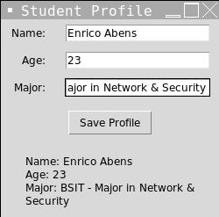

**Activity:**

import tkinter as tk

* This line imports the tkinter package, a standard Python toolkit for building graphical user interfaces.



def save_profile():  
 student_name = name_entry.get()  
 student_age = age_entry.get()  
 student_major = major_entry.get()  
 result_text.config(text=f"Name: {student_name}\nAge: {student_age}\nMajor: {student_major}")

* When you click the "Save Profile" button, this function is called. It uses the get function to retrieve the values entered in the Name, Age, and Major entry forms, and then modifies the result_text Label to display the student's profile information.



root = tk.Tk()  
root.title("Student Profile")

* This code generates the primary application window and titles it "Student Profile."

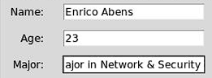

name_label = tk.Label(root, text="Name:")  
name_entry = tk.Entry(root)  
age_label = tk.Label(root, text="Age:")  
age_entry = tk.Entry(root)  
major_label = tk.Label(root, text="Major:")  
major_entry = tk.Entry(root)

* These lines generate Labels and Entry widgets for the fields Name, Age, and Major. Text is shown using labels, and text is entered using entry widgets.

result_text = tk.Label(root, text="", wraplength=200, justify="left")

* This line generates the Label widget result_text. It has no text at first and is set to wrap content inside 200 pixels and be left-justified.



save_button = tk.Button(root, text="Save Profile", command=save_profile)

* This line generates the Label widget result_text. It has no text at first and is set to wrap content inside 200 pixels and be left-justified.

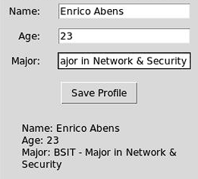

name_label.grid(row=0, column=0, padx=10, pady=5, sticky="E")  
name_entry.grid(row=0, column=1, padx=10, pady=5)  
age_label.grid(row=1, column=0, padx=10, pady=5, sticky="E")  
age_entry.grid(row=1, column=1, padx=10, pady=5)  
major_label.grid(row=2, column=0, padx=10, pady=5, sticky="E")  
major_entry.grid(row=2, column=1, padx=10, pady=5)  
save_button.grid(row=3, column=0, columnspan=2, pady=10)  
result_text.grid(row=4, column=0, columnspan=2, padx=10, pady=10)

* The grid layout manager is used in these lines to arrange the widgets in the main window. They define each widget's row and column positions, padding, and alignment.

root.mainloop()

* This line initiates the main event loop, which is required for the GUI application to respond to user input.